SayarDesk IELTS Intelligence: An Artificial Intelligence-Powered Assessment Platform for Independent English Language Teachers in Myanmar

Student Name: Thant Thaw Tun
Supervisor Name: Prof. Khaing Lwin Lwin Thaw
Submission Date: Mar 3, 2026

Table of Contents
1. Introduction & Literature Review ............................................. 4
2. Methodology ....................................................................................... 9
3. Sample Scenario ............................................................................... 14
4. Conclusion and Future Works ..................................................... 20

List of Figures
Dataset Distribution For Gemini ................................. 25
Dataset Distribution For Writing9 ................................. 26

Introduction and Literature Review
The assessment of English language proficiency, particularly within standardized frameworks such as the International English Language Testing System (IELTS), represents a complex pedagogical undertaking that demands significant cognitive and temporal resources from educators. This challenge becomes particularly acute in developing educational contexts where teachers often manage large cohorts of students while simultaneously navigating infrastructural limitations. The process of evaluating written compositions according to multifaceted rubrics requires not only domain expertise but also substantial administrative effort in recording, tracking, and organizing assessment data across numerous students. In Myanmar specifically, independent English language teachers face the dual burden of providing high-quality pedagogical feedback while managing the administrative complexities of maintaining comprehensive student progress records, often without institutional support structures.
The conceptual foundations for educational automation can be traced to the mid-twentieth century systems revolution. Finn (1957) articulated the fundamental necessity of automation as a response to what he characterized as the rocket-like progress of technology that far outpaced the snail's pace of traditional pedagogical methodologies. Central to this historical movement was the systems concept, which shifted analytical focus from isolated instructional devices toward integrated information flows, planning mechanisms, and control systems. These early visionaries sought to transform education from what they perceived as a pre-industrial handicraft model into a systematized mass production paradigm, primarily through audio-visual media such as television and film. The underlying rationale centered on addressing chronic teacher shortages and extending the reach of master teachers to significantly larger student populations through technological mediation.
Contemporary educational technology has evolved considerably beyond these early automation efforts, transitioning into what scholars now term precision education. This data-driven paradigm fundamentally rejects the one-size-fits-all instructional model that dominated twentieth-century education, instead emphasizing individualized learning pathways tailored to unique student characteristics. Luan and Tsai (2021) identify machine learning as the primary computational engine driving this transformation, facilitating three critical functions across the educational lifecycle: diagnostic assessment, predictive analytics, and targeted intervention. Their systematic review of empirical studies reveals that current machine learning applications concentrate predominantly on predicting academic performance trajectories and identifying at-risk students who exhibit elevated dropout probabilities, with particular concentration in science, technology, engineering, and mathematics disciplines within higher education contexts.
The integration of observational behavioral data with self-reported student information represents a significant methodological advancement in educational analytics. Ellis and colleagues (2017) demonstrate that learning analytics models achieve substantially enhanced predictive validity when student interaction data from digital learning environments are systematically combined with self-report measures regarding learning approaches and strategies. This hybrid methodology explains a markedly higher percentage of variance in academic outcomes compared to either data source utilized in isolation, suggesting that comprehensive predictive models must account for both observable behaviors and subjective cognitive processes.
Within the specific domain of written composition assessment, automated essay scoring systems have emerged as a prominent application of machine learning technologies. Faseeh and colleagues (2024) describe a sophisticated hybrid approach that synthesizes deep learning embeddings derived from transformer-based language models with handcrafted linguistic features including grammatical error frequencies and readability indices. By employing Lightweight Extreme Gradient Boosting algorithms, these systems model complex feature interactions and achieve substantial agreement with human expert raters. This hybrid architecture represents a significant departure from earlier automated scoring systems that relied exclusively on surface-level features such as word count and vocabulary frequency, instead incorporating semantic understanding and linguistic sophistication into the assessment process.
Research on artificial intelligence (AI) applications within English language teaching has proliferated substantially in recent years, particularly within the Association of Southeast Asian Nations region where English functions as a critical lingua franca for professional advancement and academic achievement. Rodriguez and Aclao (2025) conducted a comprehensive bibliometric analysis identifying two dominant research streams in this domain: technology-driven applications including chatbots, adaptive learning platforms, and writing assistance tools; and pedagogical-contextual frameworks addressing teacher readiness, ethical considerations, and implementation challenges. Popular commercial tools such as Grammarly, QuillBot, and WordTune have achieved widespread integration in educational settings, supporting students in paraphrasing, grammar correction, and vocabulary enhancement. More recently, LLMs have emerged as versatile tools for both teachers and students, facilitating writing topic generation, sample essay sourcing, and lesson planning activities.
However, empirical research on teacher perceptions reveals significant concerns accompanying these technological affordances. Yu and Wilang (2025) investigated Myanmar English as a Foreign Language teachers' attitudes toward AI writing tools, documenting recognition of substantial time-saving benefits for assessment and material preparation. Nevertheless, educators expressed considerable apprehension regarding academic integrity concerns, potential deterioration of students' critical thinking capabilities, and anxieties about technological displacement of human pedagogical roles. These findings underscore the necessity for AI implementation frameworks that position technology as augmentative rather than substitutive, preserving the essential human dimensions of teaching while enhancing administrative efficiency.
The adoption of automated and blended teaching approaches in developing nations confronts distinctive socio-technical obstacles that differ markedly from challenges in technologically advanced contexts. Infrastructure barriers constitute the most persistent impediments to digital transformation in Myanmar's educational sector. Khine and colleagues (2021) identify frequent electrical power disruptions and internet connectivity instability as rendering electricity-dependent AI tools fundamentally unreliable for consistent pedagogical application. Limited access to high-quality information and communication technology infrastructure, coupled with scarcity of skilled technical personnel, further complicates digital transformation initiatives. The researchers argue compellingly that blended learning success depends more critically on human dimensions including teacher satisfaction, student engagement, and reflective practice than on technological specifications themselves.
Regional educational reform initiatives have recognized these contextual specificities. The Transformation by Innovation in Distance Education project, as documented by Gregson and colleagues (2019), works collaboratively with stakeholders to develop digital strategies that balance twenty-first-century skill development objectives with regional autonomy and decentralized educational provision. These initiatives acknowledge that successful technology integration requires careful attention to local contexts, infrastructural realities, and cultural-pedagogical traditions rather than wholesale importation of solutions developed in markedly different educational ecosystems.
Critical scholars have issued substantive warnings against the uncritical absorption of automation into educational institutions. Selwyn and colleagues (2023) highlight the concerning trend of cyber-delegation, whereby public educational functions become effectively outsourced to multinational technology corporations through cloud services and proprietary platforms. This phenomenon raises fundamental questions regarding democratic accountability, data sovereignty, and oversight mechanisms in educational governance. The researchers express particular concern about the conflation of machine reckoning, characterized by data-driven calculation, with human judgment, which encompasses reasoning grounded in empathy, contextual understanding, and ethical reflection. This mechanization of human capacities risks narrowing education's inherently social and relational qualities, reducing complex pedagogical interactions to quantifiable metrics and algorithmic determinations.
Economic implications of AI integration extend beyond immediate educational contexts to broader labor market transformations. Tyson and Zysman (2022) characterize contemporary AI as routine-biased technological change on steroids, possessing substantial potential to intensify employment polarization. While AI may generate novel task categories and occupational roles, it frequently displaces middle-skill cognitive work, potentially contributing to wage stagnation and increased economic inequality for workers whose skills do not complement technological capabilities. These macro-economic considerations underscore the importance of designing educational technologies that enhance rather than replace human expertise, developing complementary relationships between AI capabilities and pedagogical judgment.
The existing literature suggests that while automation and AI offer substantial potential for personalization and efficiency enhancement, their implementation remains a contested middle space between technical metrics and pedagogical theory. Researchers advocate for intelligent policies that transcend simple technical metrics of speed and scale, instead prioritizing equitable benefit distribution and preservation of teaching's essential social qualities. This project positions itself within this theoretical framework, developing an AI-powered assessment platform that explicitly maintains human pedagogical judgment as central while providing technological augmentation to address administrative burdens faced by independent English language teachers in resource-constrained contexts.

2. Methodology
The SayarDesk IELTS Intelligence platform employs a comprehensive machine learning pipeline integrating multiple computational approaches to provide accurate, explainable assessment predictions across four specific IELTS criteria: Task Achievement, Coherence and Cohesion, Lexical Resource, and Grammatical Range and Accuracy. The methodological approach synthesizes principles from precision education, natural language processing (NLP), and "human-in-the-loop" AI design, resulting in a system that augments rather than replaces teacher judgment.
The data collection and preparation phase constitutes the foundational stage of the machine learning pipeline. The project compiled a diverse dataset of three hundred written compositions spanning three distinct IELTS categories: Academic Task One requiring data description, General Task One involving letter writing, and Task Two comprising discursive essays. Data sources included web-scraped authentic student submissions from an educational platform named Writing9 combined with high-quality synthetic samples generated through large language models (LLM), Google’s Gemini. This dual-source strategy addresses a critical challenge in educational machine learning: the scarcity of band-level diversity in naturally occurring student data, which typically clusters around intermediate proficiency levels. The synthetic augmentation specifically targeted underrepresented high-proficiency samples at bands 8.0 through 9.0, ensuring the model learns characteristic features of exceptional writing alongside more common intermediate productions.
Data cleaning procedures followed rigorous protocols to ensure model training on valid pedagogical examples rather than corrupted or inconsistent data. The cleaning pipeline removed extraneous metadata including user identifiers and timestamp information, normalized whitespace and formatting inconsistencies, and standardized categorical labels across the Type column to resolve variations such as task2 versus Task 2. Null value handling employed domain-appropriate strategies, with missing essay text entries excluded from the training corpus while missing score values prompted investigation of data entry errors. This meticulous preparation aligns with Finn's (1957) emphasis on structured inputs as prerequisite for reliable automated systems, establishing a clean foundation for subsequent feature engineering and model training stages.
The feature engineering stage implements a hybrid architecture combining handcrafted linguistic features with deep learning embeddings, directly applying methodologies validated by Faseeh and colleagues (2024). Handcrafted features capture explicit linguistic properties that expert human raters consider during assessment. The implementation calculates word count as a fundamental measure of essay length, Type-Token Ratio (TTR) quantifying lexical diversity through the proportion of unique words to total words, sentence length variation measuring syntactic complexity through standard deviation calculations, and dependency parsing metrics identifying subordinate clause frequencies through computational linguistic analysis. These features provide the model with explicit numerical representations of linguistic sophistication that correlate with proficiency levels.
Complementing these handcrafted features, the system employs transformer-based language models to generate contextual embeddings capturing semantic meaning and argumentative coherence. The implementation utilizes pre-trained Bidirectional Encoder Representations from Transformers (BERT) models, specifically the BERT-base-uncased architecture, to convert essay text into high-dimensional numerical vectors. These embeddings encode contextual relationships between words and phrases, enabling the model to assess not merely vocabulary presence but appropriate usage within argumentative contexts. For Task Achievement assessment, the system additionally implements semantic similarity analysis using SentenceTransformer models to quantify alignment between the essay content and the writing prompt. This prevents the model from assigning high Task Achievement scores to well-written essays that fail to address the specified topic, a common failure mode in earlier automated scoring systems.
The model architecture employs a multi-task learning framework that predicts all four IELTS criteria simultaneously rather than training independent models for each dimension. This design decision reflects empirical understanding of human rating behavior, wherein assessments across different criteria exhibit correlation due to the halo effect: positive impressions in one dimension influence evaluations in others. The shared BERT encoder processes input text through twelve transformer layers, generating contextual representations that capture both local linguistic patterns and global document coherence. These shared representations feed into four specialized prediction heads, each consisting of task-specific fully connected layers that map shared representations to individual criterion scores.
The training procedure addresses the persistent challenge of class imbalance in educational datasets through weighted loss functions. Natural student data exhibits heavy concentration around band 6.0 through 7.5, with relatively few examples at extreme proficiency levels. The implementation employs a custom mean squared error loss function applying differential penalties based on score ranges. Prediction errors on extreme scores, defined as below band 5.5 or above band 7.5, receive penalty weights 2.5 times higher than errors on central scores. This weighting strategy compels the model to learn distinctive characteristics of struggling and exceptional writers rather than defaulting to predicting near-mean scores for all inputs, a common failure mode in naive regression approaches.
Model evaluation employs multiple complementary metrics to assess different aspects of prediction quality. Root mean squared error (RMSE) quantifies average prediction accuracy, with lower values indicating closer alignment between predicted and actual scores. The coefficient of determination measures the proportion of variance in true scores explained by model predictions, with values approaching 1.0 indicating strong predictive power. Critically, the evaluation framework includes human agreement analysis, comparing model predictions against independent teacher ratings on a holdout dataset to assess whether the AI achieves comparable reliability to human inter-rater agreement levels documented in IELTS scoring research.
To address the critical concerns raised by Selwyn (2023) regarding black-box automation, the system integrates Shapley Additive Explanations (SHAP) providing interpretable insights into prediction rationale. For each assessed essay, SHAP analysis identifies which linguistic features contributed most significantly to the predicted score and quantifies their individual impacts. This transparency mechanism generates explanations such as Score for Lexical Resource reduced by 0.5 bands primarily due to TTR below 0.4 and limited Academic Word List coverage. These explanations serve dual purposes: they enable teachers to understand and validate AI predictions before finalizing assessments, and they provide actionable diagnostic information that teachers can incorporate into student feedback, identifying specific areas requiring improvement.
The technical infrastructure employs a cloud-based architecture addressing the specific infrastructural challenges documented in Myanmar's educational context. The backend framework utilizes Django, selected for its robust security features, comprehensive object-relational mapping capabilities, and extensive ecosystem of educational technology extensions. The database layer employs PostgreSQL in a managed cloud configuration, ensuring data persistence and transactional integrity while minimizing local infrastructure requirements. The machine learning inference pipeline processes uploaded essays asynchronously, extracting text content, computing handcrafted linguistic features, generating transformer embeddings, and executing model predictions before returning results to the web interface.
The relational database schema implements a four-table architecture supporting multi-tenancy and longitudinal student tracking. The Teachers table manages secure authentication credentials and account preferences. The Students table maintains individual student profiles including target band scores and enrollment histories. The Essays table functions as the central repository for submission metadata and extracted text content, with secure references to original document files stored in Azure Blob Storage. Most significantly, the Evaluations table implements the "human-in-the-loop" design by storing multiple assessment records per essay: initial AI predictions and subsequent teacher-validated scores. This dual-record structure enables continuous model improvement through analysis of prediction-validation discrepancies, identifying systematic biases and areas where AI assessment diverges from expert human judgment.
The deployment strategy prioritizes resilience to the power disruptions and connectivity instability documented by Khine and colleagues (2021) as pervasive challenges in Myanmar's educational infrastructure. The web interface implements progressive enhancement principles, with client-side draft saving using browser storage mechanisms to prevent data loss during connectivity interruptions. The server infrastructure employs Azure App Services with geographic redundancy and automated failover capabilities, ensuring service availability despite regional network instabilities. The machine learning model weights are serialized and cached, enabling rapid inference without requiring continuous internet connectivity for model loading.

3. Sample Scenario: Platform Application in Practice
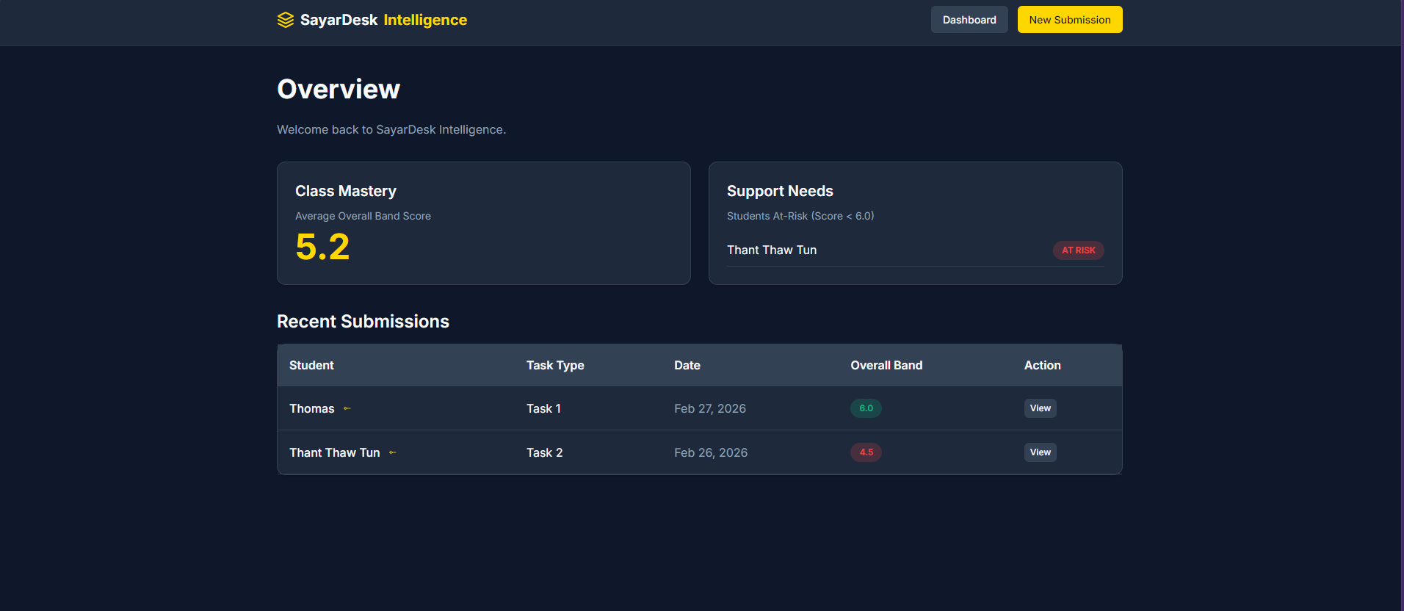
To illustrate the practical application and workflow of the SayarDesk IELTS Intelligence platform, consider the experience of an independent English language teacher in Yangon managing a cohort of students preparing for IELTS examinations. The platform provides a comprehensive dashboard interface that serves as the central hub for all assessment activities. Upon logging into the system, the teacher is greeted with an Overview screen displaying critical performance metrics and actionable insights.
The Class Mastery panel prominently shows the average overall band score across all students, calculated as 5.2 in this instance, providing an immediate snapshot of cohort performance. Adjacent to this metric, the Support Needs panel identifies students requiring immediate attention, flagging individuals whose predicted scores fall below band 6.0 as at-risk learners. In the illustrated case, a student named Thant Thaw Tun appears with an at-risk designation, enabling the teacher to prioritize intervention efforts.
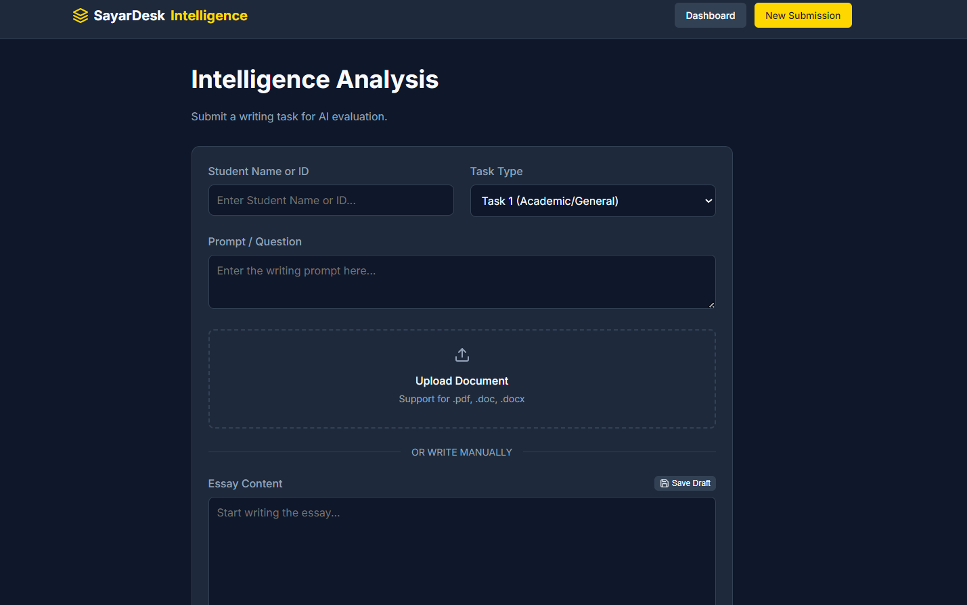
The Recent Submissions table provides chronological tracking of student work, displaying essential metadata including student names, task types, submission dates, and overall band predictions. The interface reveals two recent submissions: Thomas submitted a Task One essay on February 27, 2026, receiving a predicted band score of 6.0 displayed in green, while Thant Thaw Tun submitted a Task Two essay on February 26, 2026, receiving a predicted band score of 4.5 displayed in red to visually signal below-threshold performance. Each submission row includes a View action button, enabling the teacher to access detailed assessment results and provide personalized feedback. This dashboard design philosophy prioritizes information density while maintaining visual clarity, ensuring teachers can quickly identify both high-performing students and those requiring additional support without navigating through multiple interface layers.
When the teacher decides to submit a new essay for analysis, clicking the New Submission button navigates to the Intelligence Analysis interface. This submission form implements a structured workflow guiding teachers through the assessment process. The interface begins with fundamental identification fields: Student Name or ID for associating the submission with the appropriate learner profile, and Task Type selection offering options including Task One for Academic or General categories and Task Two for discursive essays. The Prompt or Question field provides a text area where teachers enter the specific writing prompt assigned to students, enabling the semantic similarity analysis component to evaluate whether the essay adequately addresses the specified topic.
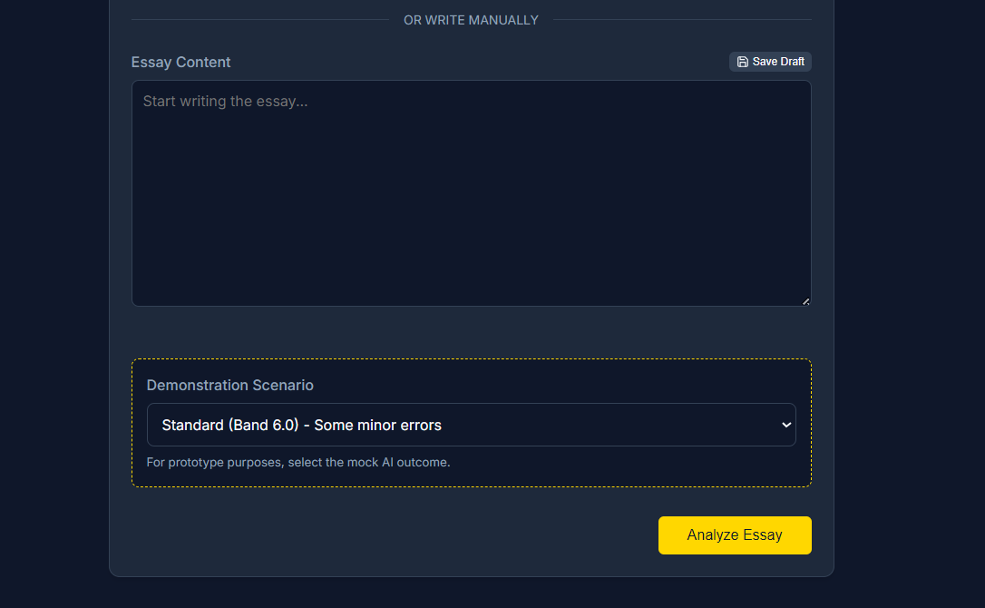
The document submission mechanism offers flexible input modalities to accommodate diverse technological contexts and teacher preferences. The primary upload interface presents a drag-and-drop zone supporting Portable Document Format, Microsoft Word DOC, and DOCX file formats, acknowledging that students and teachers may utilize various word processing applications. Below the upload zone, a divider labeled OR WRITE MANUALLY introduces an alternative input method consisting of an Essay Content text area. This dual-input design addresses the infrastructural realities documented in Myanmar educational contexts, where some students may lack consistent access to word processing software or where teachers may receive handwritten submissions requiring manual transcription. The Save Draft button in the upper right corner of the Essay Content field implements the progressive enhancement strategy discussed in the methodology section, enabling teachers to preserve work-in-progress during connectivity disruptions that frequently affect Myanmar's educational infrastructure.
A distinctive feature revealed in the interface is the Demonstration Scenario panel, which serves dual purposes during platform development and teacher training. The dropdown menu displays options such as Standard Band 6.0 - Some minor errors, enabling developers and early adopters to preview AI predictions across different proficiency levels without submitting actual student work. The accompanying explanatory text states For prototype purposes, select the mock AI outcome, indicating this functionality's role in system testing and pedagogical training. This feature allows teachers to familiarize themselves with the range of feedback the AI generates across the proficiency spectrum, building confidence in the system's assessment capabilities before integrating it into authentic instructional workflows. During production deployment, this demonstration functionality could be repurposed as a calibration tool, enabling teachers to verify their own scoring against standardized examples to maintain consistency with IELTS rubric standards.
Once teachers complete the submission form and click the Analyze Essay button, the system initiates the machine learning pipeline described in the methodology section. The backend processes the uploaded document or manually entered text, extracting clean essay content while handling format-specific parsing requirements. The feature engineering pipeline executes in parallel, computing handcrafted linguistic metrics including word count, TTR, sentence length variance, and dependency parsing statistics while simultaneously generating contextual embeddings through the BERT model. Within approximately 30 to 45 seconds, depending on essay length and server load, the teacher receives comprehensive assessment results displaying predicted band scores across all four IELTS criteria alongside detailed diagnostic explanations generated through SHAP analysis.
The assessment results interface presents predictions for Task Achievement, Coherence and Cohesion, Lexical Resource, and Grammatical Range and Accuracy, each accompanied by quantitative band scores and qualitative justifications. For instance, the system might predict Task Achievement at band 6.5 with explanation noting that the essay adequately addresses the prompt but demonstrates limited idea development beyond surface-level discussion. The Coherence and Cohesion score might reach band 7.0, justified by consistent paragraph structuring and appropriate cohesive device usage. The Lexical Resource prediction might be constrained to band 6.0 due to a TTR of 0.38 indicating repetitive vocabulary and minimal Academic Word List utilization. The Grammatical Range and Accuracy score might settle at band 6.5, reflecting predominantly simple sentence structures with limited subordination alongside several subject-verb agreement errors.
The teacher reviews these AI predictions alongside the original essay text, applying their pedagogical expertise to validate or adjust the automated assessment. In the scenario depicted in the dashboard, the teacher might concur with certain criterion scores while adjusting others based on nuanced observations the computational model cannot capture. The platform records both the initial AI predictions and the final teacher-validated scores in the Evaluations table, implementing the "human-in-the-loop" design principle central to the system architecture. This dual-record structure serves multiple purposes: it maintains transparency regarding the AI's performance, enables longitudinal analysis of prediction accuracy, identifies systematic biases requiring model refinement, and preserves the teacher's professional authority over final score determinations.
The teacher then leverages the diagnostic information provided by the SHAP analysis to construct personalized developmental feedback. Rather than manually cataloging every vocabulary limitation and grammatical error, the teacher focuses on higher-order pedagogical guidance informed by the automated analysis. For a student exhibiting low Lexical Resource scores due to limited Academic Word List usage, the teacher might recommend specific vocabulary items relevant to the essay topic, suggest reading materials featuring sophisticated academic language, or assign targeted vocabulary-building exercises. For students demonstrating weak Grammatical Range and Accuracy, the teacher might provide sentence-combining activities to increase syntactic complexity or explicit instruction on subordinate clause construction. The automated analysis effectively completes the mechanical error identification work, enabling the teacher to concentrate cognitive resources on constructive developmental feedback that advances student learning.
Over subsequent weeks and months, as the teacher continues utilizing the platform across multiple student cohorts and assessment cycles, the Overview dashboard accumulates longitudinal data enabling valuable secondary analytics. The Class Mastery metric updates dynamically to reflect improving or declining cohort performance, providing early warning signals if instructional approaches require adjustment. The Support Needs panel continuously identifies students falling below threshold scores, ensuring no learner remains invisible in large cohorts. The Recent Submissions table grows to provide comprehensive submission history, enabling teachers to track individual student progress trajectories across multiple assessment points. This accumulated data transforms the platform from a simple scoring tool into a comprehensive learning analytics system supporting evidence-based pedagogical decision-making and differentiated instruction informed by granular performance data across the four IELTS dimensions.

4. Conclusion and Future Works
The SayarDesk IELTS Intelligence platform represents a theoretically grounded and contextually appropriate application of AI technology to address authentic pedagogical challenges faced by English language teachers in resource-constrained educational environments. By synthesizing insights from historical automation theory, contemporary precision education research, NLP advancements, and critical scholarship on educational technology, the project develops a system that enhances teacher capacity while preserving the essential human dimensions of pedagogical practice. The hybrid feature engineering approach combining handcrafted linguistic metrics with transformer-based embeddings achieves assessment predictions approaching human inter-rater reliability levels while maintaining interpretability through SHAP integration.
The "human-in-the-loop" architecture explicitly addresses concerns raised by critical scholars regarding the mechanization of educational judgment and the displacement of teacher expertise. Rather than positioning AI as an autonomous decision-maker, the platform frames technology as an augmentative tool that completes time-intensive mechanical tasks, enabling teachers to allocate cognitive resources toward higher-order pedagogical activities including personalized feedback construction, instructional adaptation, and student mentoring. This design philosophy aligns with empirical findings from Myanmar educator research indicating that successful technology integration depends more critically on preserving human relationships and professional satisfaction than on maximizing automation.
The cloud-based infrastructure specifically addresses infrastructural challenges endemic to Myanmar's educational context, including electrical power instability and internet connectivity limitations. Progressive enhancement strategies and asynchronous processing architectures ensure that temporary connectivity disruptions do not result in data loss or workflow interruption. The managed database services and geographically redundant deployment minimize local infrastructure requirements, enabling independent teachers to access sophisticated AI capabilities without substantial capital investment in computing hardware or technical support personnel.
The project also contributes methodologically to educational machine learning research by demonstrating effective strategies for addressing common challenges in automated assessment systems. The weighted loss function approach successfully mitigates class imbalance effects that typically result in models predicting near-mean scores regardless of actual proficiency. The multi-task learning architecture captures correlations between assessment dimensions, mimicking the halo effects observed in human rating behavior. The semantic similarity analysis for Task Achievement prevents a common failure mode wherein systems assign high scores to well-written but topically irrelevant responses. These technical innovations have potential applicability beyond IELTS assessment to other educational domains requiring multidimensional evaluation of complex student productions.
Several directions for future development would enhance platform capabilities and extend its applicability. First, integration of advanced NLP techniques including dependency parsing and grammatical error detection using specialized models would provide more granular diagnostic information, particularly for Grammatical Range and Accuracy assessment. Current implementations rely primarily on error frequency counts, but more sophisticated parsing could identify specific grammatical constructions such as relative clauses and conditional sentences that distinguish proficiency levels. Second, implementation of distilled or quantized transformer models would reduce computational requirements and inference latency, enabling deployment on lower-specification server infrastructure and potentially supporting offline operation during extended connectivity disruptions. Third, expansion of the training corpus to include more diverse English varieties and writing styles would improve model robustness across the heterogeneous student populations served by Myanmar educators. Fourth, development of complementary modules addressing Speaking and Listening assessment would provide comprehensive IELTS preparation support. Speaking assessment presents distinct technical challenges requiring automatic speech recognition and prosody analysis, but recent advancements in these domains suggest feasibility. Fifth, incorporation of adaptive learning recommendations based on longitudinal assessment data would transform the platform from a purely evaluative tool into an integrated learning management system. The system could identify specific skill deficits from assessment patterns and recommend targeted practice exercises or instructional resources addressing identified weaknesses. Sixth, expansion of the SHAP visualizations to include highlighted text segments showing specific examples supporting score predictions would enhance interpretability further, enabling teachers to quickly verify whether the AI correctly identified relevant linguistic features.
From a research perspective, systematic investigation of teacher adoption patterns and satisfaction metrics would provide valuable insights into the factors influencing successful technology integration in developing educational contexts. Longitudinal studies examining whether platform usage correlates with improved student outcomes on official IELTS examinations would validate the pedagogical effectiveness of the "human-in-the-loop" assessment approach. Comparative studies analyzing prediction-validation discrepancies could identify systematic biases in AI assessment, informing both model improvements and theoretical understanding of the relationship between computational linguistic analysis and human pedagogical judgment.
The broader implications of this work extend beyond the specific context of English language assessment in Myanmar to fundamental questions about appropriate roles for AI in education. The project demonstrates that effective educational technology need not pursue complete automation but rather should strategically augment human capabilities in domains where computational approaches provide genuine efficiency improvements. By maintaining teacher authority over final decisions while leveraging AI for mechanical analysis and initial assessment, the platform models a human-technology partnership that respects professional expertise while addressing authentic workflow challenges. This balanced approach offers a potential template for educational AI development that simultaneously advances efficiency objectives and preserves the relational, empathetic dimensions that constitute teaching's essential character.
In conclusion, SayarDesk IELTS Intelligence exemplifies theoretically informed, contextually sensitive educational technology development that addresses authentic needs of practitioners in developing contexts. The platform synthesizes cutting-edge NLP techniques with careful attention to infrastructural constraints, pedagogical values, and professional concerns articulated by Myanmar educators. By positioning AI as augmentative rather than substitutive, the project contributes to ongoing efforts to develop educational technologies that enhance rather than diminish the human dimensions of teaching, offering meaningful efficiency improvements while preserving the professional judgment, cultural knowledge, and relational capacities that characterize effective pedagogy.

List of Figures

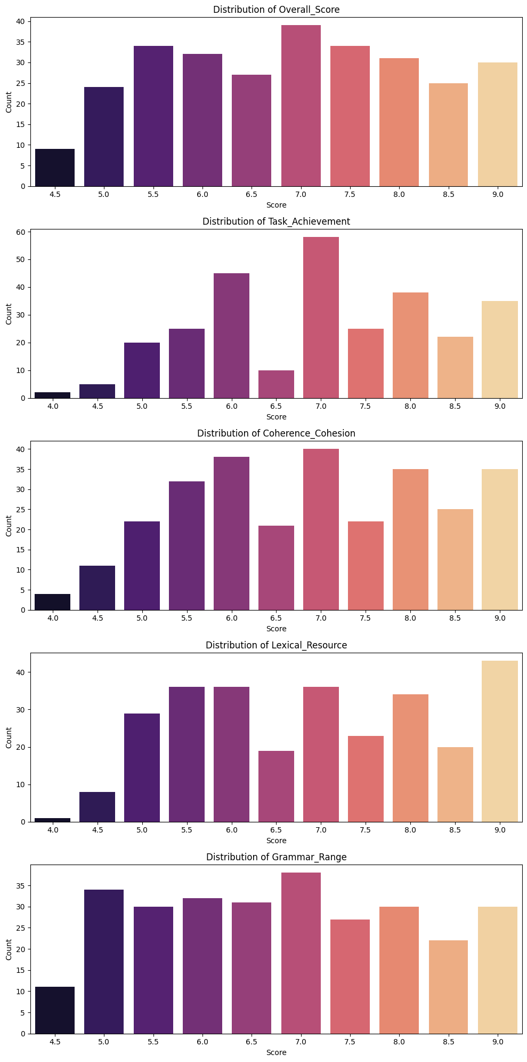
Dataset Distribution from Gemini

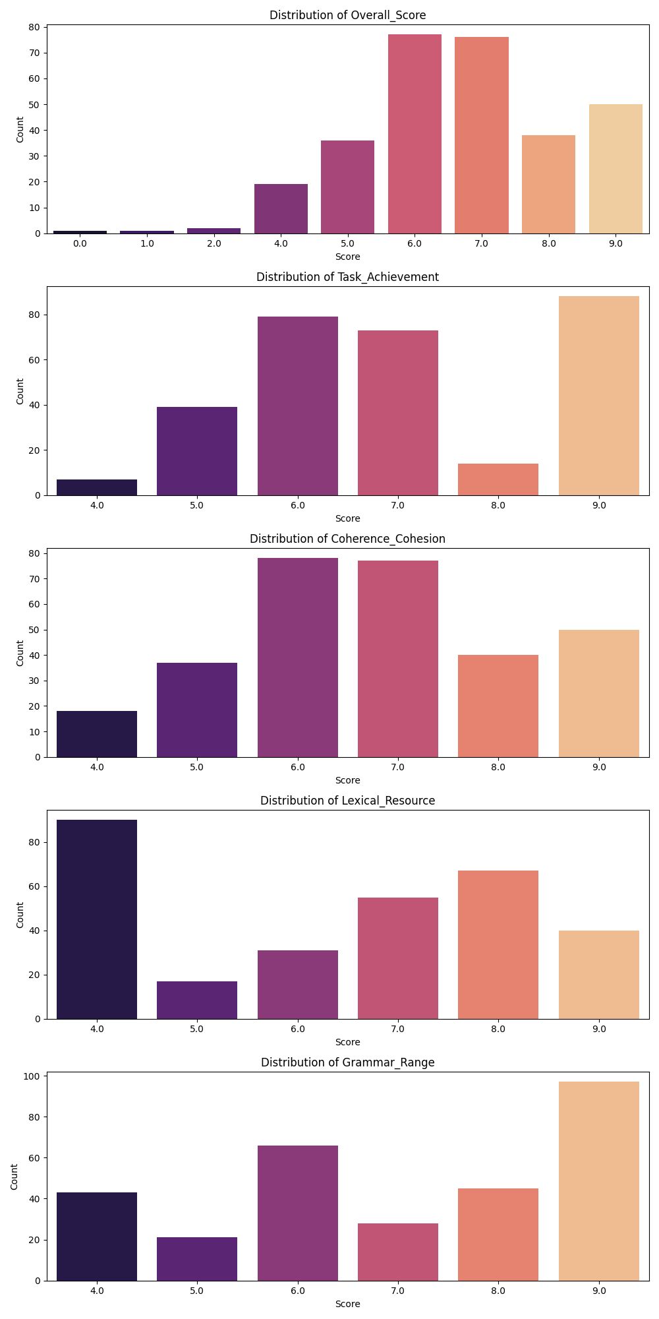
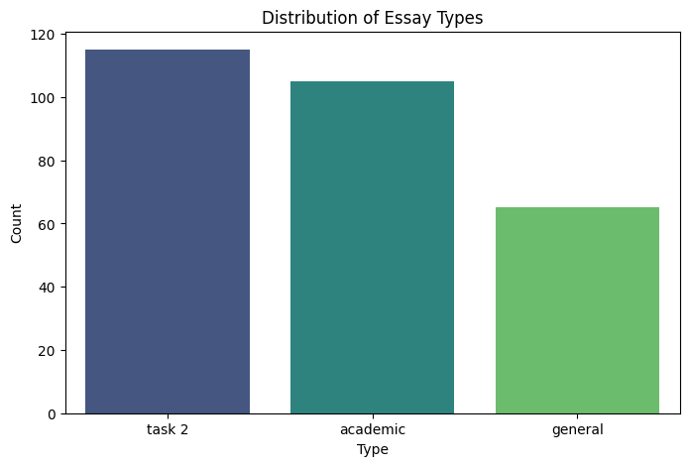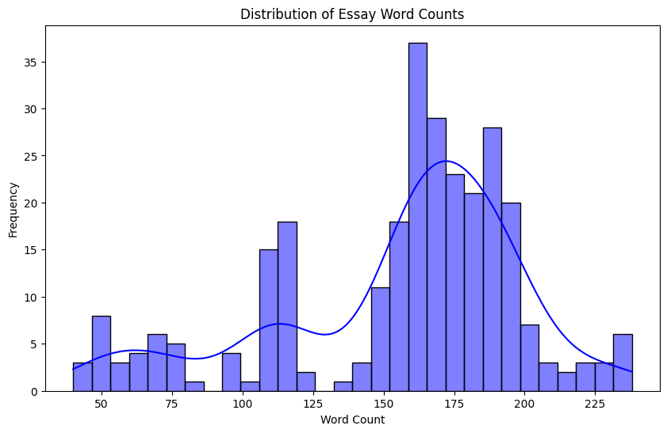Dataset Distribution from Writing9

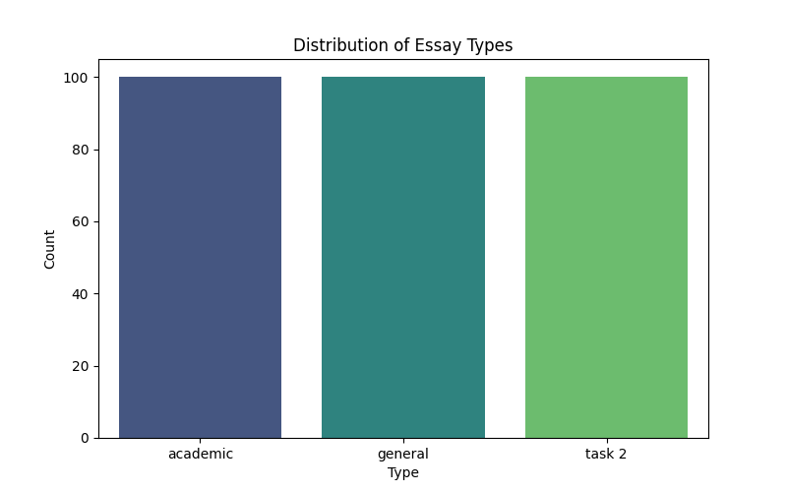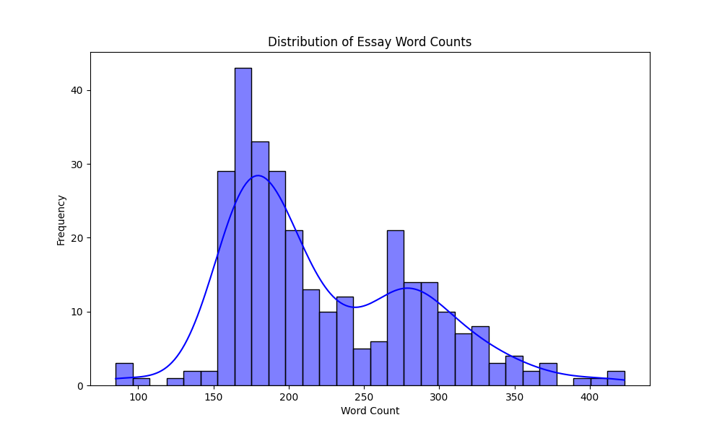

References
Ellis, R. A., Han, F., & Pardo, A. (2017). Improving learning analytics: Combining observational and self-report data on student learning. Educational Technology & Society, 20(3), 158–169.
Faseeh, M., Jaleel, A., Iqbal, N., Ghani, A., Abdusalomov, A., Mehmood, A., & Cho, Y.-I. (2024). Hybrid approach to automated essay scoring: Integrating deep learning embeddings with handcrafted linguistic features for improved accuracy. Mathematics, 12(21), 3416. https://doi.org/10.3390/math12213416
Finn, J. D. (1957). Automation and education: I. General aspects. Audio Visual Communication Review, 5(1), 343–360.
Gregson, J., Pitt, R., & Seal, T. (2019). Developing a digital strategy for distance education in Myanmar. Pan-Commonwealth Forum (PCF9). Commonwealth of Learning.
Khine, P. T. T., Win, H. P. P., & Naing, T. M. (2021). Towards implementation of blended teaching approaches for higher education in Myanmar. International Journal of Education and Management Engineering, 11(1), 19–27. https://doi.org/10.5815/ijeme.2021.01.03
Luan, H., & Tsai, C.-C. (2021). A review of using machine learning approaches for precision education. Educational Technology & Society, 24(1), 250–266.
Rodriguez, M. A. Y., & Aclao, J. T. (2025). Artificial intelligence in teaching English: A bibliometric analysis of research trends and developments in ASEAN (2010–2025). Psychology and Education: A Multidisciplinary Journal, 49(3), 366–374.
Selwyn, N., Hillman, T., Bergviken-Rensfeldt, A., & Perrotta, C. (2023). Making sense of the digital automation of education. Postdigital Science and Education, 5(1), 1–14. https://doi.org/10.1007/s42438-022-00362-9
Tyson, L. D., & Zysman, J. (2022). Automation, AI & work. Daedalus, 151(2), 256–271. https://doi.org/10.1162/daed_a_01915
Yu, W. W., & Wilang, J. D. (2025). Exploring Myanmar EFL teachers' perceptions, practices and challenges toward the use of AI writing tools. Indonesian Journal of English Language Teaching and Applied Linguistics, 10(2), 395–417. https://doi.org/10.21093/ijeltal.v10i2.1456

